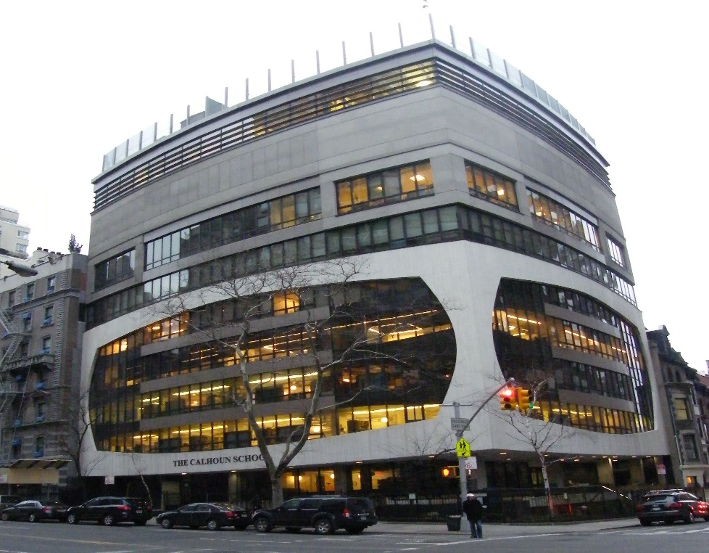

MINIMUM CAPACITY :-

The Minumum intake capacity

of students is between 300-620

children

LIBRARY :-

The Libarary is Available.

CANTEEN:-

The Canteen Facility is Available.

BOARDING :-

No availablility of boarding.

SPORTS :-

There are different categories

sports available.

Girls Volleyball

Boys Volleyball

Football

|  |  |  |
| --- | --- | --- |
| THE CALHOUN SCHOOL  YONKERS - SCHOOL |  |  |
|  |  |  |
| School Detail :- As Manhattan’s open-concept school, our classrooms—and our way of learning—seek to break down barriers between and within disciplines, concepts and people in order to nurture flexibility, provoke inquiry and forge instructive connections.  As Manhattan’s open-concept school, our classrooms—and our way of learning—seek to break down barriers between and within disciplines, concepts and people in order to nurture flexibility, provoke inquiry and forge instructive connections. |  |